Glucagon Information

What is glucagon?
- Glucagon is a hormone that stimulates the liver to release stored glucose. This causes the blood glucose (blood sugar) level to rise.
- Glucagon has the opposite effect of insulin. Insulin LOWERS the blood glucose level, glucagon RAISES the blood glucose.
- All students with Type 1 diabetes need to inject insulin daily because their body no longer produces enough/any insulin. It is difficult to calculate exactly how much insulin is needed due to changes in meal time, meal size and activity. If there is more insulin in the body than needed, low blood glucose can result. Sometimes the glucose level is so low the student with diabetes becomes unresponsive.
- A student having an extreme low blood glucose level may be confused, lethargic or even unconscious and may experience a seizure. They are unable to treat the low blood glucose orally themselves or with assistance because they can’t safely swallow. This is a life threatening emergency.
- The hormone glucagon is available as a synthetic product that is given by injection.
- Injectable glucagon is safe and there is no risk of giving “too much” as high blood glucose may be treated later with insulin.
- Severe low blood glucose, seizures and glucagon may all cause vomiting. Whenever a student is not fully conscious, they should be turned onto their side to keep their airway open and clear. Stay with the student and monitor breathing until emergency services arrive.

When is glucagon given?
- The table below reviews levels of typical low blood glucose symptoms and required treatment.
- Glucagon is given when the student with diabetes has severe symptoms of a low blood glucose level and oral treatment is not possible.
- Follow specific Emergency Health Plan for individual students if available.
Low Blood Glucose (sugar)
 | Mild | Moderate | Severe
Symptoms | Shakiness, sweating, hunger, change in personality, dizziness, headache. | Confusion, agitation, sleepiness, decreased coordination or reflexes, slurred speech. | Student is unable to swallow due to extreme lethargy, unconsciousness or seizures.
Action Needed | - The student needs to take a quick acting sugar (carbohydrate) orally such as 3-4 glucose tablets, 4-6 ounces of juice or regular pop, 8 ounces of milk, etc.  - Students usually check their blood sugar prior to oral treatment and 15-20 minutes after oral treatment to ensure blood glucose has risen into accepted range. | - Assist the student immediately (without checking their blood glucose first) to drink juice, regular soda etc. if able to swallow.  - Glucose gel may be used in cheek/gums.  - Stay with the student until they have recovered and blood glucose level is up to an accepted range.  - Notify school nurse/parent | - Administer glucagon if trained and authorized.  - Activate the emergency system and have 911 called  - Protect student from injury from falling, seizure or choking; turn onto side.  - Delegate call to parent/school nurse.

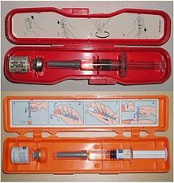
Emergency Glucagon Administration Instructions
It is recommended that this information be reviewed periodically in order to administer glucagon readily in an emergency.

Student Name: ______________________________________________
Usual location of glucagon: _____________________________________
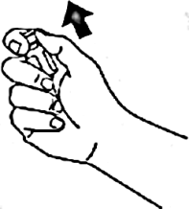
Dose ordered: ____________________
Administer all contents (1mg/1 ml) unless otherwise noted
Mixing and preparing glucagon:
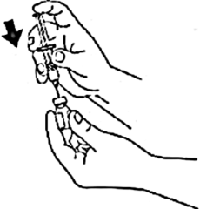
- If readily available, may put on gloves.
- Glucagon is the powder and must be mixed JUST prior to injection.
A
- Remove the flip off seal (cap) from the bottle of powdered glucagon.
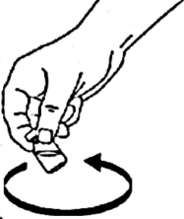
- If readily available, may wipe the rubber stopper with an alcohol pad. Remove the rubber protector from the needle on the syringe. Inject the entire liquid contents of the syringe into the vial of glucagon powder.
B
- Gently swirl bottle to mix; solution
should be clear. If possible, leave the syringe
C
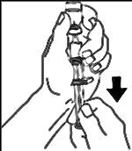
in place while mixing.
D
- Using the same syringe, hold the bottle upside down and making sure the tip of the needle remains in the solution, gently withdraw the desired amount of the solution.
(All the solution unless otherwise specified)
- If large air bubbles are present, gently “flick” syringe and push plunger to dispel.

Injecting the prepared glucagon:
- Glucagon is given in either the muscle or the fat tissue.
- Inject the entire syringe contents into the upper, outer thigh or the upper arm. Glucagon can be injected through clothing if needed when using the glucagon kit needle and syringe.
- Withdraw needle quickly and if available, press alcohol pad or cotton ball to area.
- Do not re-cap needle. Place entire syringe into orange case and close case.
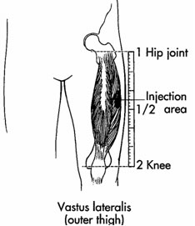  ← Location for muscle injection in thigh  Inject needle at 90 ° angle | 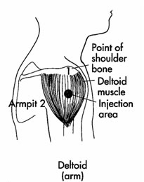  ←Location for muscle injection in arm  Inject needle at 90° angle | 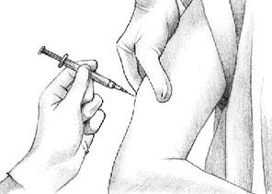  Location for fat injection in arm: Pinch up skin in back of arm and inject at 45° angle →
- Make sure 911 has been called. Keep student on their side. Check for normal breathing (if student was having a seizure normal breathing may not resume until after the seizure has stopped). If seizure has ended but student is not breathing, start the steps of CPR.
- If emergency services do not readily arrive (example: on field trips), check/have the student check their blood glucose (BG) level upon awakening. Student may not awaken for 15+ minutes. Treat BG under 150 with juice/regular pop if student able to safely swallow. Re-check at 30 minute intervals until emergency services arrive.

