Montana K-12 School Air Purifier Order Sheet

Email completed form to aaron.boock@grainger.com
Facility (School) Name:
Shipping Address:
POC Name: Telephone: Email:
Air Purifier Units (each unit will be delivered with a 3-year supply of HEPA filters, 6 filters per unit)

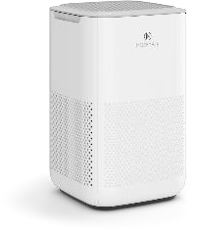
MA-15 For small rooms under 165 sq. ft. Grainger Product #’s: Unit: 78UU22, Filter: 78UU24 CADR: 150m3/h |Power: 18W
Number of rooms =
MA-15 units =
Electric Voltage: 110-120V / 60HZ
Max Noise: < 51dBA | Net Weight: 6.64 LBS
Dimensions: 15.5”H x 9.7”W x 9.7”D

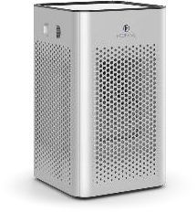
MA-25 For small rooms under 250 sq. ft. Grainger Product #’s: Unit: 78UU27, Filter: 78UU30 CADR: 230m3/h | Power: 28W
Number of rooms = MA-25 units =

Electric Voltage: 110-120V / 60HZ
Max Noise: < 52dBA | Net Weight: 7.3 LBS Dimensions: 13.5”H x 8”W x 8”D

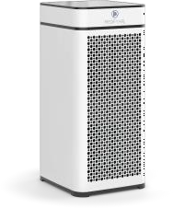
MA-40 For small rooms under 420 sq. ft. Grainger Product #’s: Unit: 78UU25, Filter: 78UU26 CADR: 380m3/h | Power: 68W
Number of rooms =
MA-40 units =
Electric Voltage: 110-120V / 60HZ
Max Noise: < 66dBA | Net Weight: 15.6 LBS
Dimensions: 22”H x 9.9”W x 10.9”D

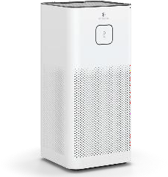
MA-50 For medium rooms under 550 sq. ft. Grainger Product #’s: Unit: 78UU19, Filter: 78UU21 CADR: 500m3/h | Power: 70W
Number of rooms =
MA-50 units =

Electric Voltage: 110-120V / 60HZ
Max Noise: < 56dBA | Net Weight: 16 LBS Dimensions: 12.4”H x 12.4”W x 24.69”D

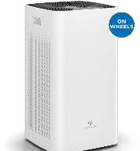
MA-112 for Classrooms up to 1,050 sq. ft. Grainger Product #’s: Unit: 78UU16, Filter: 78UU18 CADR: 950m3/h | Power: 95W
Number of rooms =
MA-112 units =

Electric Voltage: 110-120V / 60HZ
Max Noise: < 70dBA | Net Weight: 33.5 LBS Dimensions: 28.3”H x 15.7”W x 15.4”D

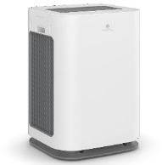
MA-125 – Classrooms up to 1025 sq. ft. Grainger Product #’s: Unit: 78UV35 (White), 78UV36 (Black), Filter: 78UV37 CADR: 930m³/h (547 CFM)
Number of rooms =
MA-125 units =
Power: 132W | 9 Fan Speeds Max noise: < 67 dB | N.W. 32 LBS
Dimensions: 16.6' X 15.7" X 23.4"

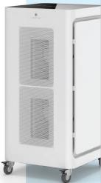
MA-1000 – For large rooms up to 1,875 sq. ft. Grainger Product #’s: Unit: 78UU31 Filter: 78UU32 CADR: 1700m3/h | Power: 200W
Number of rooms =
MA-1000 units =
Electric Voltage: 120V / 60HZ
Max Noise: < 66 dBA | Net Weight: 88 LBS
Dimensions: 22.8”L x 22.8”W x 47.2”H

All above recommendations are for 4 air exchanges per hour

Official Use Only:
Total order:
= MA-125 (including 3 years of replacement filters)

= MA–1000 (including 3 years of replacement filters)
= MA–112 (including 3 years of replacement filters)
= MA–15 (including 3 years of replacement filters)

= MA–25 (including 3 years of replacement filters)

= MA–40 (including 3 years of replacement filters)

= MA–50 (including 3 years of replacement filters)
Authorized Signature
AUTHORIZED SIGNATURE

