Montana Centers for Independent Living
CIL Logo | CIL contact information
 | Living for Today and Tomorrow (LIFTT)  - Main office: Billings  - Satellite office(s): Glendive  - Billings Phone: (406) 259-5181  - Glendive Phone: (406) 948-8500  - Website: liftt.org
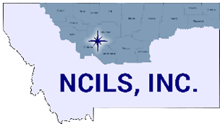 | North Central Independent Living Services (NCILS)  - Main office: Great Falls/Black Eagle  - Satellite office(s): Glascow, Conrad  - Phone: (800) 823-6245  - Website: ncils.org
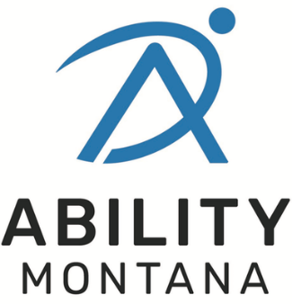 | Ability Montana (formerly mILp)  - Office(s): Helena, Bozeman, Butte  - Helena Phone: (406) 442-5755  - Bozeman Phone: (406) 522-7300  - Butte Phone: (406) 782-4834  - Website: abilitymt.org
 | Summit Independent Living  - Main office: Missoula  - Satellite office(s): Polson, Kalispell, Ronan  - Phone: (800) 398-9002  - Website: summitilc.org
