**ServiceNow Communities – Subscribing and Notifications**

Access the Montana ServiceNow Communities site by going to <https://montana.servicenowservices.com/community>.

**Subscription Types**

* Subscribe or unsubscribe to forums (top level), topics (inside the forum), and community content (questions, answers, blogs, and video).
* Auto-subscribe: Whenever you post content, you are automatically subscribed to the content itself. You are also automatically subscribed when you post a reply or a comment.

**How to subscribe to content and receive notifications for that content –**

**Important** - To receive email notifications on updates regarding an item, you MUST subscribe to that item.

1. Expand the forums list to find a forum, topic, or any community content you would like to be notified of.

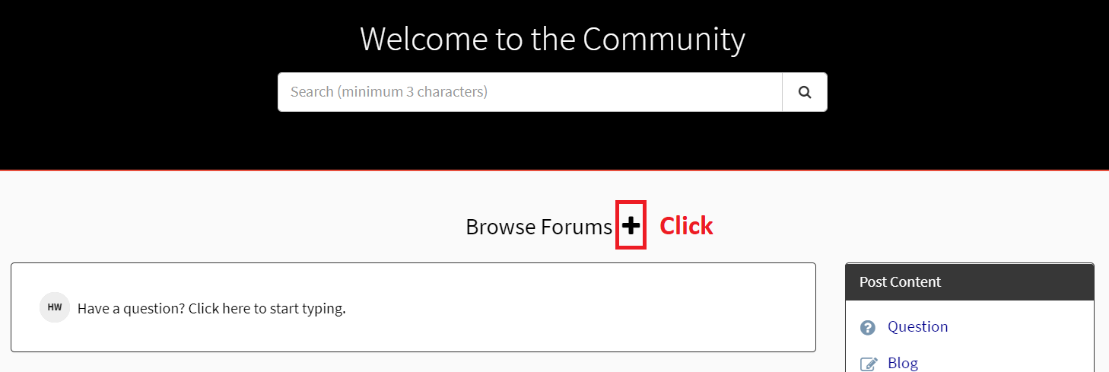

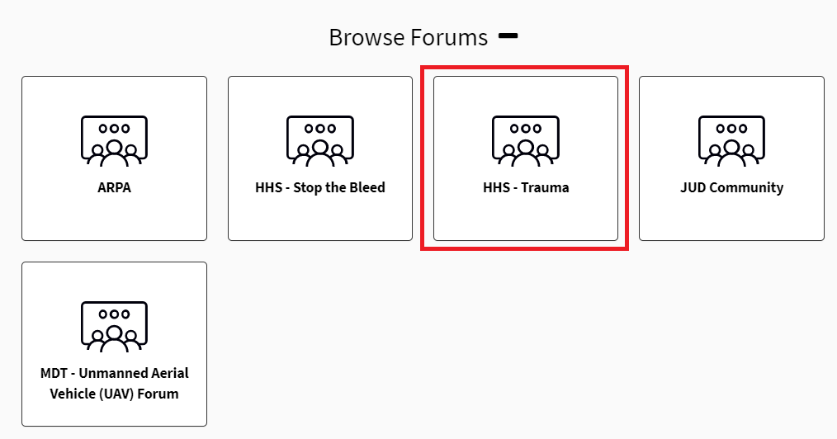

1. Select a forum, or content item you want to subscribe to and click ‘Subscribe’.

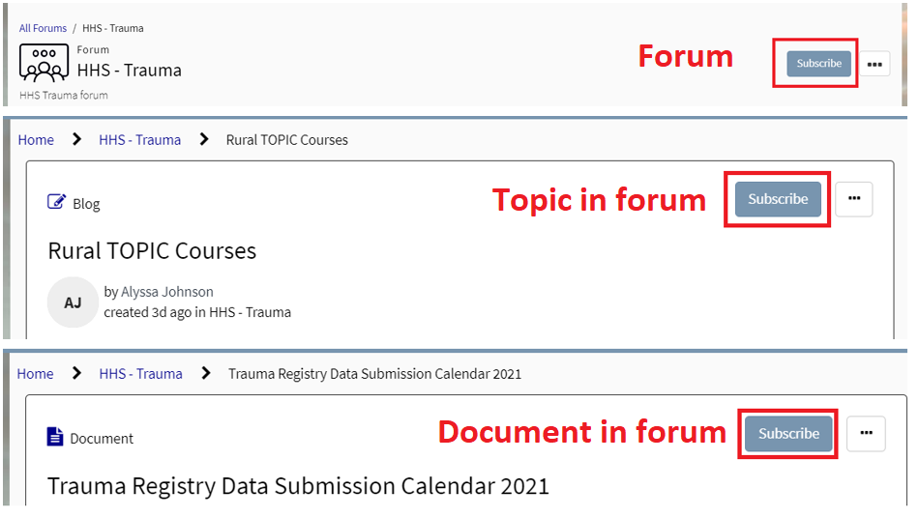

1. Subscribing to a forum will notify you when anything is posted in that forum whether it’s a new forum topic or content (documents, videos, posts, questions, answers, blogs, etc.).
   1. Subscribing to any topic or content INSIDE the forum, will notify you for updates made specifically to that item you subscribed to.
   2. You can be subscribed to the forum an specific content in that forum at the same time.

**How to check your subscriptions and notifications -**

1. Once you have subscribed to any forum, topic, content, etc., go to “Community” in the upper right-hand corner.

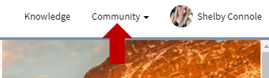

1. Select “Notifications and Subscriptions” in the drop down.
2. Here you will find options to turn on notifications and manage subscriptions for “Community”.

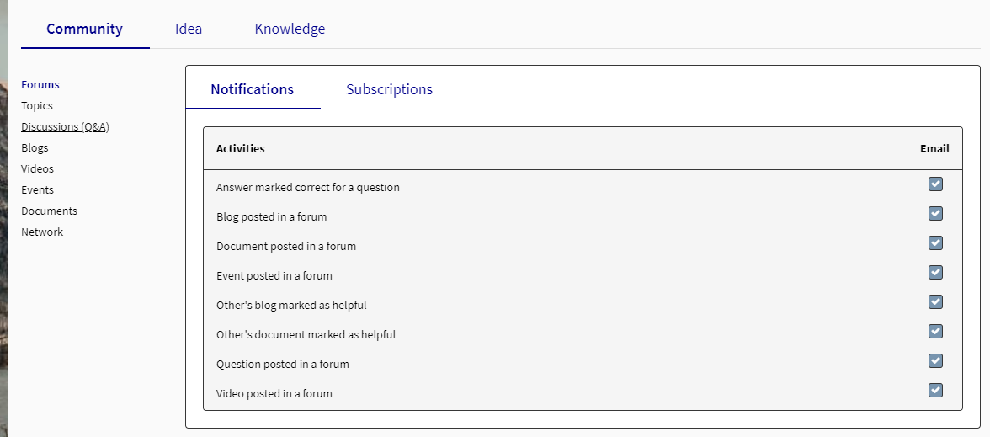

1. Choose your preferences and choose “Save” in the bottom right-hand corner.
2. Follow the same steps to subscribe to any type of community content, forums and topics and the same steps to update any notification preferences.