Fingerprint Cards
Example
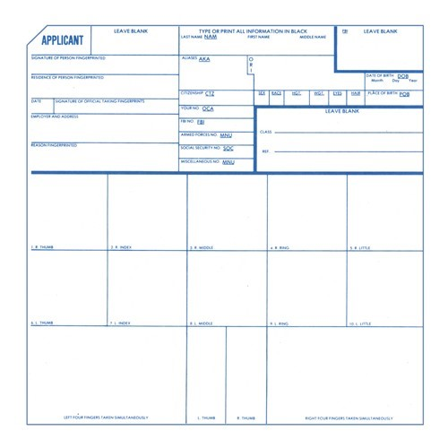
Doe
Jane
Jane Doe
Brown, Jane
Smith, Jane
Margaret
MT
025025
Y

th
1234 5

Ave
Helena, MT 59601
/9/19
1
Audra Ferris
01
01 1976

F
I
130
506

B
ro
B
ro
MT
DPHHS PAARP BOARD

NCPA/VCA
Position applying for
123-45-6789
US
MT
VX00133
Each fingerprint card should be examined to ascertain all information that is required on the fingerprint card has been provided and is legible. Incomplete cards will not be processed and will be mailed back. All fingers need to be in the correct position and rolled. To avoid delays, ask the requestor of the background check or call Montana Criminal Records at (406) 444-3625 for assistance.

